NAME: K Yamini
REG NO: 192572181

Write a Python program to implement Alpha-Beta Pruning algorithm for gaming.
Aim:
To implement Alpha-Beta Pruning to optimize the Minimax algorithm by reducing the number of nodes evaluated.
Algorithm:
- Represent the game tree (or board).
- Define two players:
  - Maximizer (X)
  - Minimizer (O)
- Initialize:
  - Alpha = -∞ (best for maximizer)
  - Beta = +∞ (best for minimizer)
- Define recursive function:
  - If Maximizer → maximize value and update alpha
  - If Minimizer → minimize value and update beta
- Apply pruning:
  - If alpha ≥ beta → stop exploring branch
- Base conditions:
  - Win/Loss/Draw
- Continue until best move is found
- Print best move and pruning steps
Python Code:
# Alpha-Beta Pruning for Tic-Tac-Toe
board = ['X', 'O', 'X',
'O', 'O', 'X',
' ', ' ', ' ']
# Display board
def display():
print("\nBoard State:")
for i in range(0, 9, 3):
print(board[i], "|", board[i+1], "|", board[i+2])
print()
# Check winner
def check_winner(b):
win_conditions = [
[0,1,2], [3,4,5], [6,7,8],
[0,3,6], [1,4,7], [2,5,8],
[0,4,8], [2,4,6]
]
for cond in win_conditions:
if b[cond[0]] == b[cond[1]] == b[cond[2]]:
if b[cond[0]] == 'X':
return 1
elif b[cond[0]] == 'O':
return -1
return 0
# Check moves left
def is_moves_left(b):
return ' ' in b
# Alpha-Beta function
def alphabeta(b, depth, alpha, beta, is_max):
score = check_winner(b)
# Terminal state
if score == 1 or score == -1:
return score
if not is_moves_left(b):
return 0
if is_max:
best = -100
for i in range(9):
if b[i] == ' ':
b[i] = 'X'
val = alphabeta(b, depth+1, alpha, beta, False)
b[i] = ' '
best = max(best, val)
alpha = max(alpha, best)
print("# Maximizer checking pos", i+1, "Value:", val)
# Pruning condition
if beta <= alpha:
print("# Pruning at position", i+1)
break
return best
else:
best = 100
for i in range(9):
if b[i] == ' ':
b[i] = 'O'
val = alphabeta(b, depth+1, alpha, beta, True)
b[i] = ' '
best = min(best, val)
beta = min(beta, best)
print("# Minimizer checking pos", i+1, "Value:", val)
# Pruning condition
if beta <= alpha:
print("# Pruning at position", i+1)
break
return best
# Find best move
def find_best_move(b):
best_val = -100
best_move = -1
for i in range(9):
if b[i] == ' ':
b[i] = 'X'
move_val = alphabeta(b, 0, -100, 100, False)
b[i] = ' '
print("# Evaluating move", i+1, "Score:", move_val)
if move_val > best_val:
best_move = i
best_val = move_val
return best_move
# Run
display()
best_move = find_best_move(board)
print("\nBest Move for X is position:", best_move + 1)
print("# Alpha-Beta selected optimal move efficiently")
Input:
Initial Board:
X O X
O O X
_ _ _

Output :
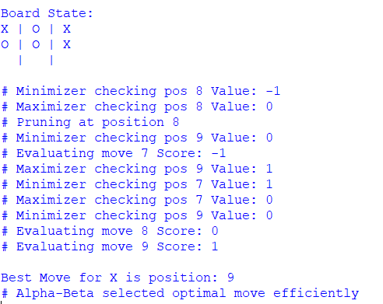
Result:
The Alpha-Beta Pruning algorithm is successfully implemented and efficiently finds the optimal move by eliminating unnecessary computations.

